Homework 10 – Austin Rippee

QUESTION #1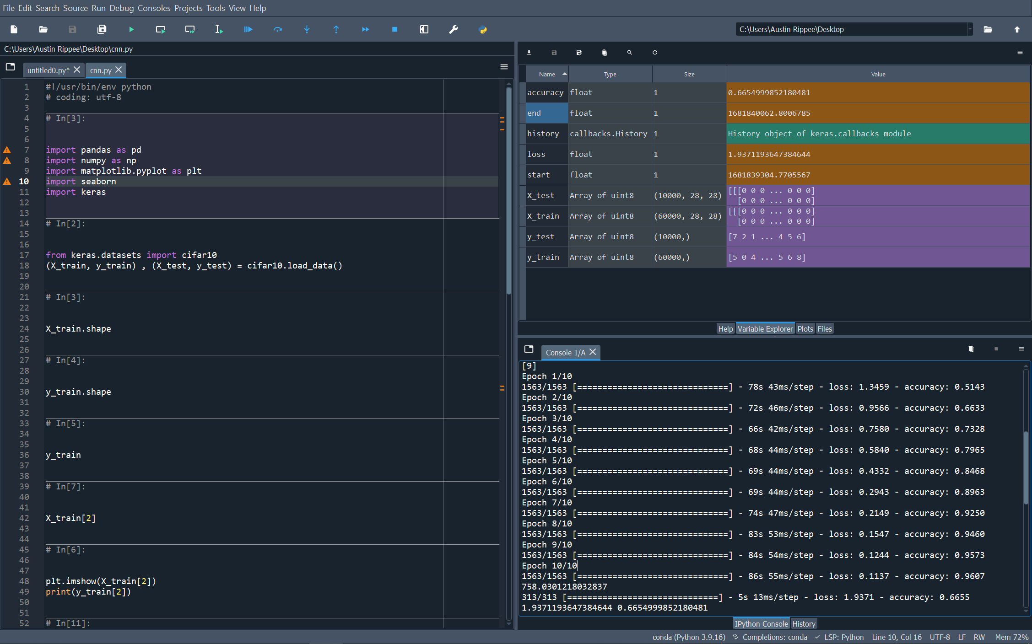

QUESTION #2a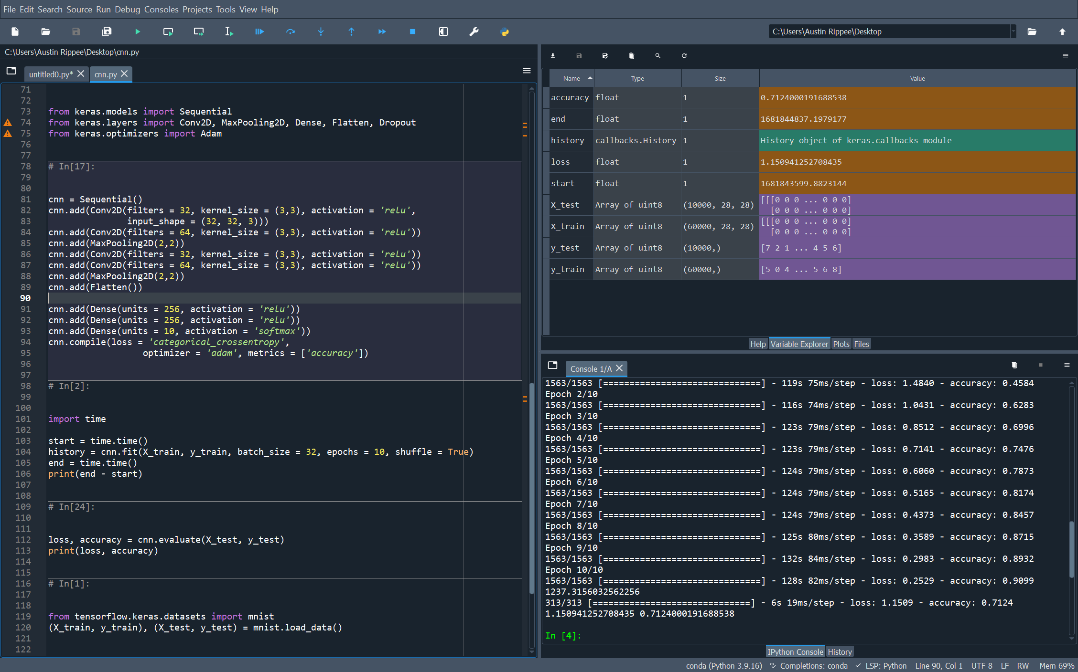

QUESTION #2c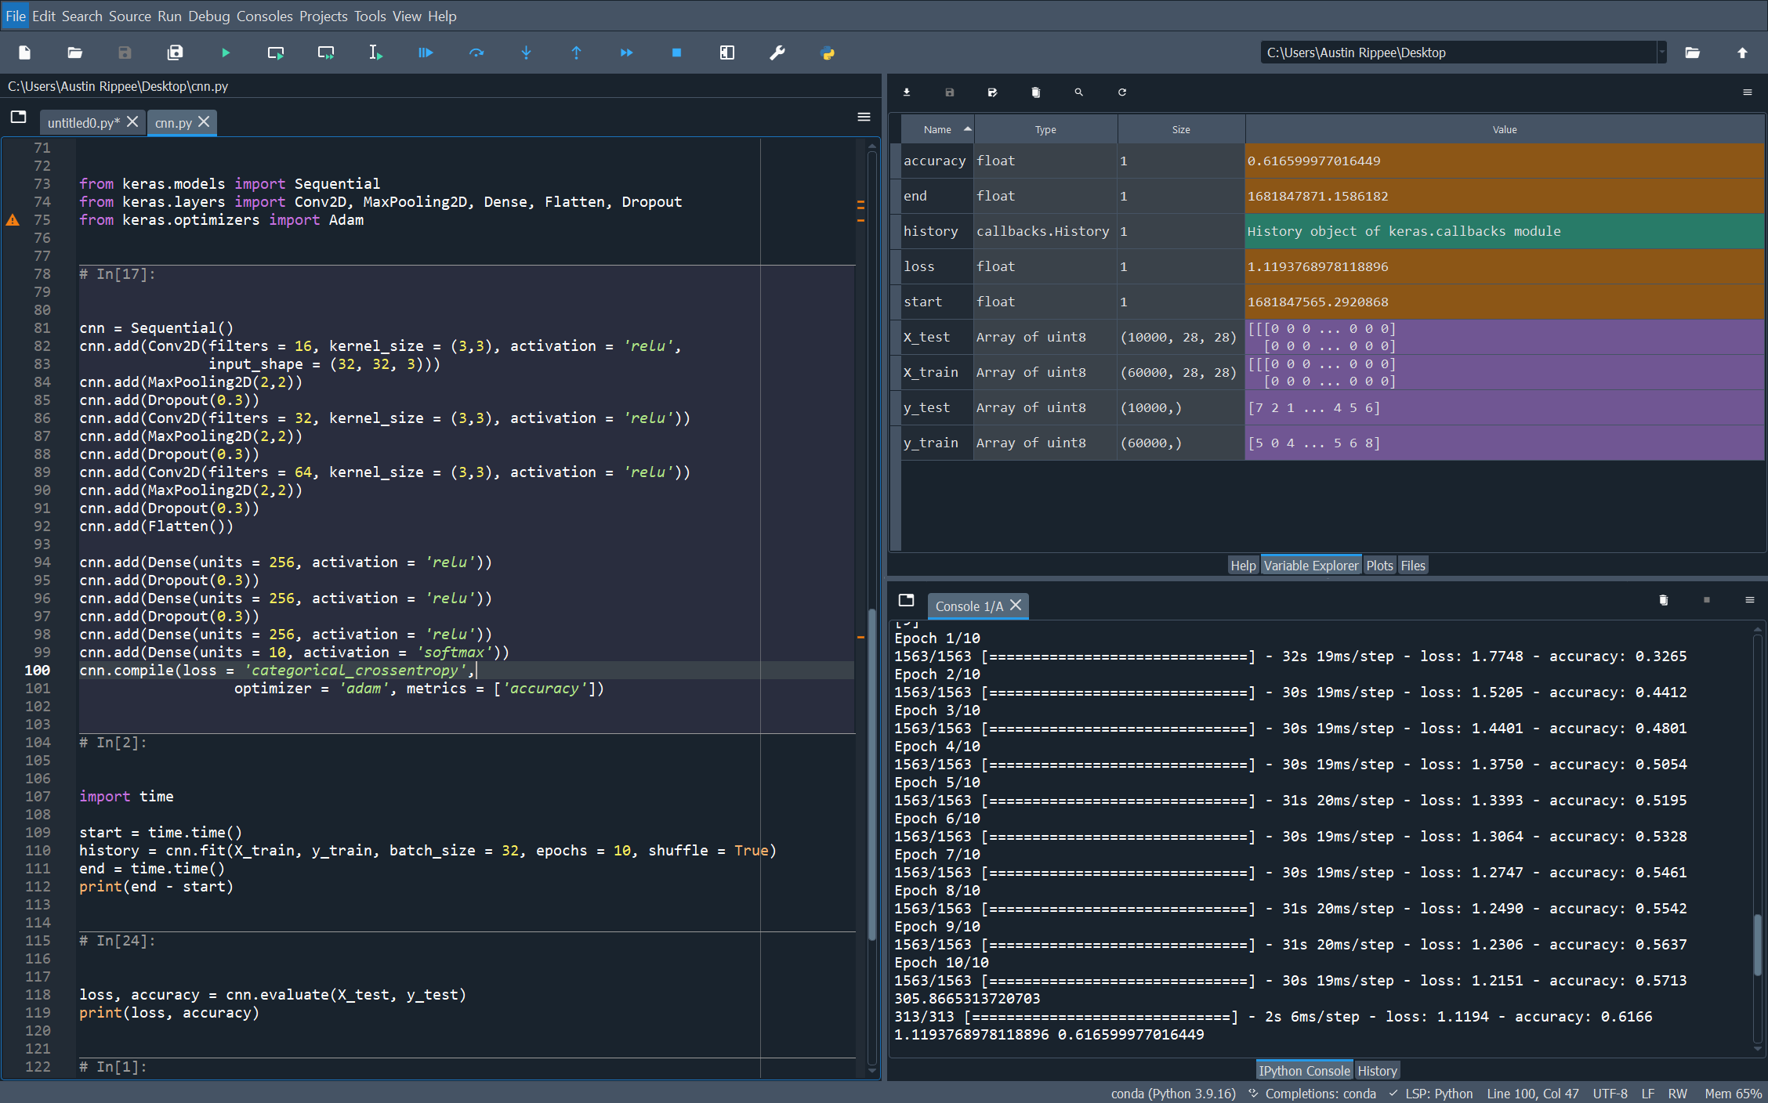

QUESTION #3

